Language Attitudes

- Categorization
  - Importance of categorization for human cognition
  - Understand new experiences in relation to old ones
  - Categories: overlook differences, focus on similarities
    - Ex: “car”
  - Economical for our brain: Why?
  - Knowledge of category lets us identify and make inferences about possible members
    - Here’s where the trouble begins…
  - Social categories
    - Macro and micro (e.g. ethnicity and neighborhood gang)
    - Stereotypes: reduce complexity to a single social image
      - Examples?
- Perceptual Dialectology
  - Mental maps of dialect boundaries
  - What are people’s attitudes toward different varieties?
  - How do we elicit mental maps and attitudes: Mapping task

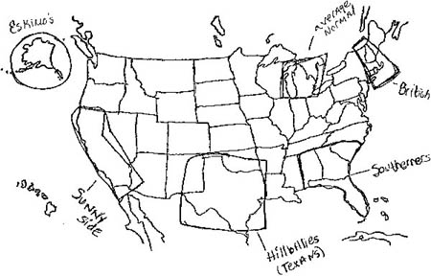

Fig 1: Michigan hand-drawn map

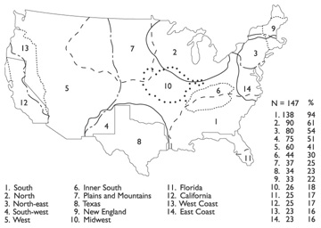

Fig 2: Computer-assisted generalization of hand-drawn maps

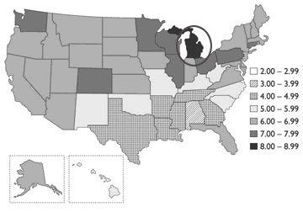

Fig 3: Mean ratings of language “correctness” by Michigan respondents
for US English (on a scale of 1 to 10, where 1- least and 10 = most correct)

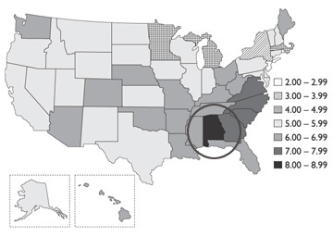
Fig 4: Mean ratings of language “pleasantness” by Alabamian respondents
for US English (on a scale of 1 to 10, where 1- least and 10 = most pleasant)

- Labov’s work on language attitudes in NY
  - Recordings of NY women reading a passage twice
    - “He darted out about four feet before a car and got hit hard”
    - Once with all r’s, another time with one r deleted
    - These called “consistent r” and “inconsistent r”, respectively
  - Played these for people from three social groups (working, lower middle, and upper middle class)
  - Judged on seven point scale (“occupational suitability”)
    - TV personality – exec secretary – receptionist – switchboard operator –
salesgirl – factory worker – none of these
  - “Inconsistent r” rated significantly lower on scale
  - What does this tell us about our ability to perceive variation?

- Linguistic Discrimination
  - How we perceive variation, our preconceptions, have consequences for employment
  - Also problems with housing
  - Ex: John Baugh
    - Called about apartment for rent
    - Used 3 different varieties (AAE, Chicano, “standard”), left a message
    - Which got most call backs?

